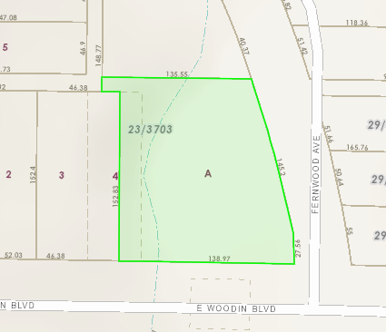
FERNWOOD AVENUE
DDD
Block 23/3703

E. Woodin Boulevard

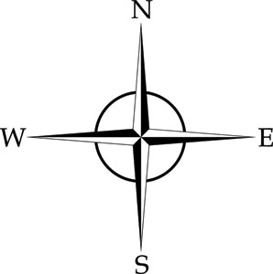
SUBJECT: 3,644 Sq. Ft. Drainage Easement

